

ITA0324-Mobile Computing

Name: A. Anusha Reg no:192472083

Slot: C Course Name: Mobile Computing

Experiment 14: GPRS Operation Flowchart
Aim: To develop a flowchart explaining the operation of General Packet Radio Service (GPRS).
Procedure:
- Open Figma and create a new design file.
- Create a frame for the GPRS operation flowchart.
- Add the mobile station as the starting point.
- Add BTS and BSC to represent the radio access part of the network.
- Include SGSN for mobility management and GPRS session support, and GGSN for connectivity to external packet networks.
- Connect the components with arrows to show packet transmission and add authentication and connection decision points.
- Apply different colors and labels, then review the complete flowchart.

Output:

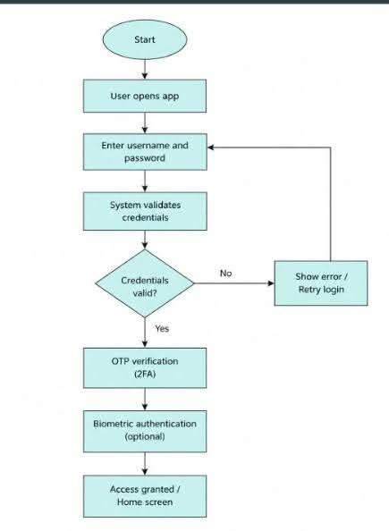

Result: Thus, a flowchart explaining the operation of GPRS and packet data transmission was developed successfully using Figma.

